MODUAL-3

# What are the four important < meta> tags we use in SEO?

1. Title Tags, to name your page on search engines.
2. Meta Description Tags, to describe your page search.
3. Robots Meta Tags, to index or not index page.
4. No follow sponsored, and user-generated content Meta tags, four outbound links.

## What is the use of open-graph tags in a website?

The four basic open graph tags that are required for each page are og: title, og: type, og: image, and og: URL. These tags should be unique for each page you serve, meaning your homepage’s tags should all be different from your blog post article’s page.

* Og: title: The title of your page. This is typically the same as your webpage’s <title> tag unless you’d like to present it differently.
* Og: type: The “type” of website you have. I’ll explain more in the next section, though a generic “type” is “website”.
* Og: image: This should be a link to an image that you’d like to represent your content. It should be a high resolution image that the social network will use in their feeds.
* Og:url : This should be the URL of the current page.

When placing a tag on your website, you should place it in the <head> along with any other metadata. The tag used will be a <meta> tag and should look like this pattern:

<meta property =”og: title” content = “ rajkotdm - Surface Ornamentation &amp ; Fashion designer blog” />

<meta property =”og: type” content =”website” />

<meta property =”og: image” content =”/static/ />

<meta property =”og: url” content =”www.rajkotdm.blogspot.com />

## What tag we will use to add an image to the website? Explain the points we should care about while adding the image to the website.

* In HTML image are used for inserting image in our web page.

For inserting image we have to used <img> Tag

Example:-

<body>

<im gsrc=”file///c|/user/public/pictures/sample

pictures/Desert.jpg” width=50px” height=”50px”/>

</body>

* In the above example, if we have to insert an image in our webpage
* In <img> tag we use src. In src, we have to write o select the path of the image where the image stored in our computer

We also set the height and width of the Image using the height and width property of <img> tag.

## What is the difference between NOFOLLOW and NOINDEX?

* NOINDEX: Page may not be indexed by a search service.

<meta name=”robots” contect=”noindex”>

* NOFOLLOW: Robots are not to follow links from this page

<meta name=”robots” content=”nofollow”>

# Explain the type of queries.

* Transactional Queries
* Informational Queries
* Navigation Queries

Transactional Queries –Are queries where the user wants to do something like buy a phone. If you are selling phone and you have pricing of phones with reviews then the user can look at the prices, user reviews and then he can buy the phone.

Information Queries – Are queries where the user is looking for information. How is a truck made or how do I lose weight. How can you effectively service these queries say you have a hotel in Switzerland your site has month wise weather in Switzerland it would enable the user to visit your page get an answer from there he can also look at your hotel property and potentially book it for his next vacation.

Navigation Queries – Search of a certain product/service-When a user is specifically looking for a product by brand – an example would be you searching for facebook.com on Google and clicking on the results.

# What is the importance of site Map and Robot.txt in SEO?

Sitemap and robots.txt are two important files in SEO that help search engines to crawl and index your website’s pages efficiently. Here’s a brief explanation of their importance:

1. Sitemap: A sitemap is an XML file that contains a list of all the pages on your website that you want search engines to index. It helps search engines to discover and understand the structure of your site and its content. By submitting a sitemap to search engines, you can ensure that all the pages on your site are indexed, even If they are not linked to from other pages.
2. Robots.txt: A robots.txt file is a text file that tells search engine crawlers which pages or sections of your website should not be crawled or indexed. It is placed in the root directory of your website and is used to prevent search engines from indexing pages that you don’t want to be indexed. This can include pages that are duplicates, low-quality pages, or pages with sensitive information.

In summary, sitemaps are important because they help search engines to understand the structure of your site and index all the pages you want them to. Meanwhile, robots.txt is important because allows you to control which pages or sections of your site should not be indexed, ensuring that only the pages you want to be ranked appear in search engine results pages.

Example:

**sitemap (2).xml**

[**https://www.seoptimer.com/rajkotdm.blogspot.com**](https://www.seoptimer.com/rajkotdm.blogspot.com)

# Below is the list of pages for an e-commerce site that doesn’t need to be crawled by any crawler.

* **Admin pages**
* **Cart page**
* **Thank -you page**
* **Images**

# How will you achieve this?

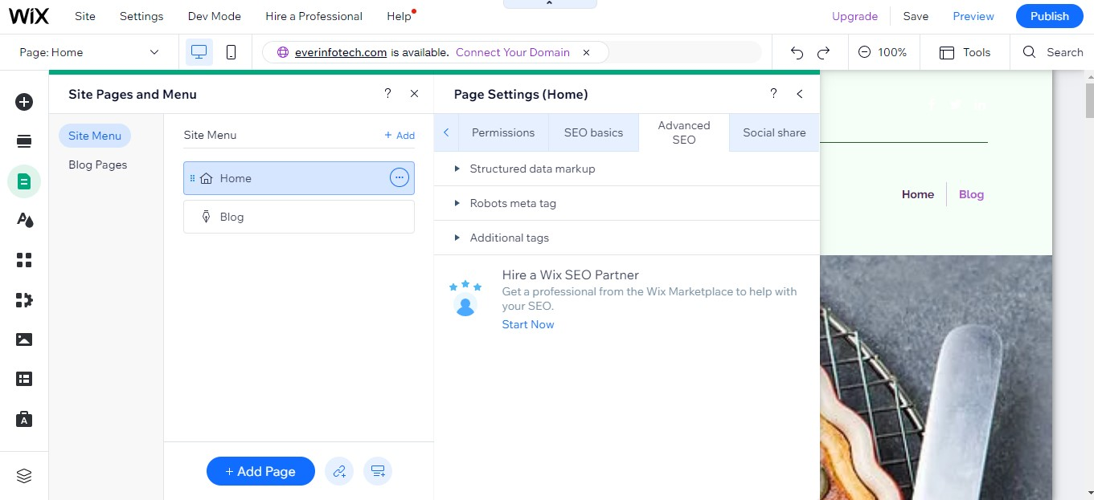

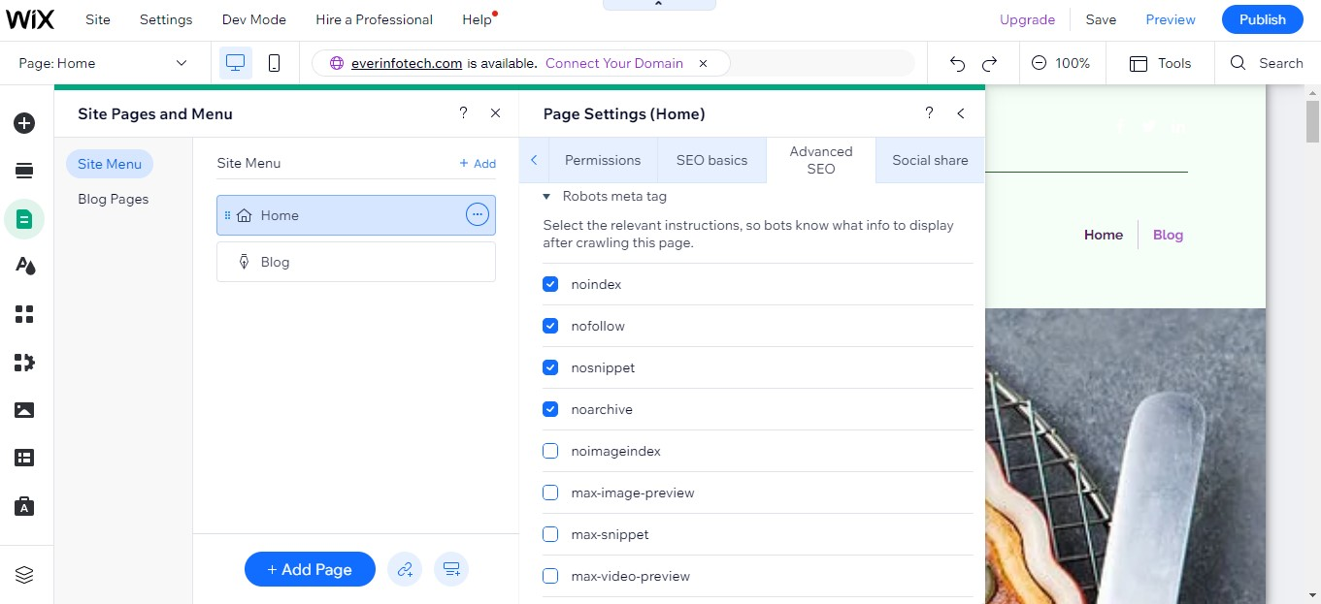

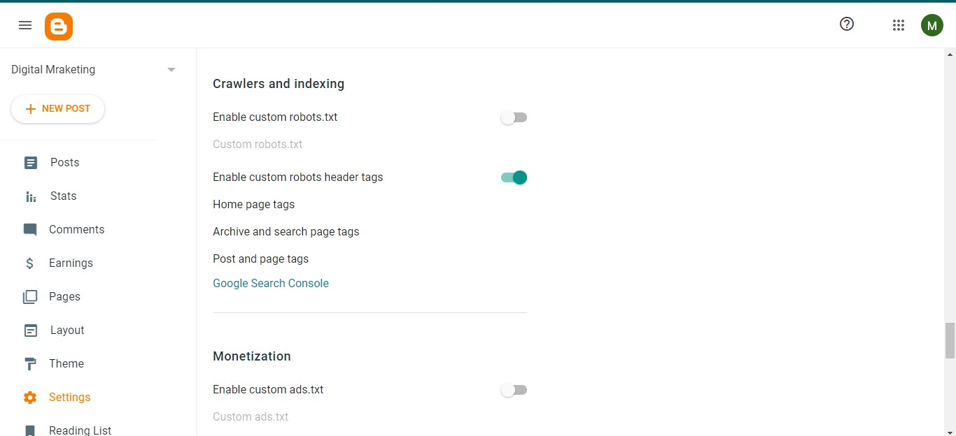

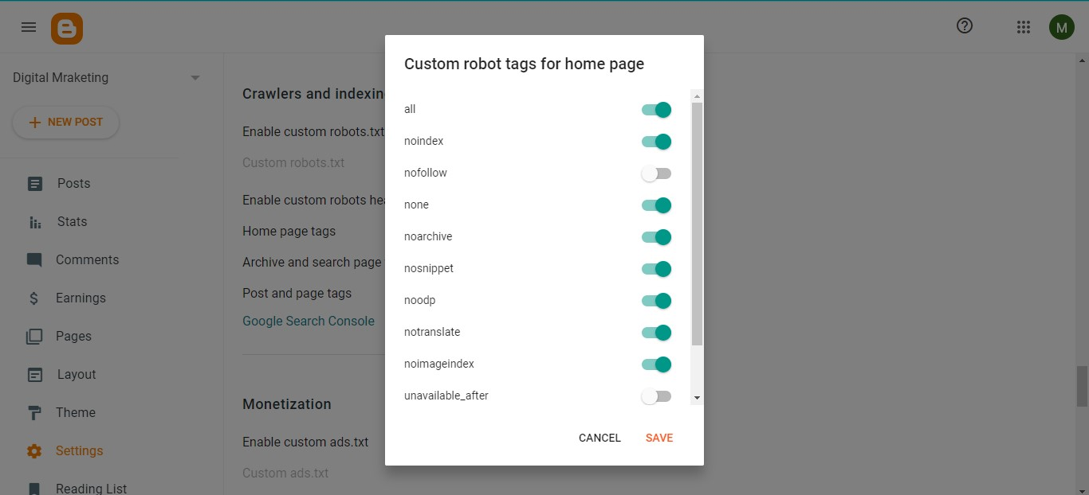

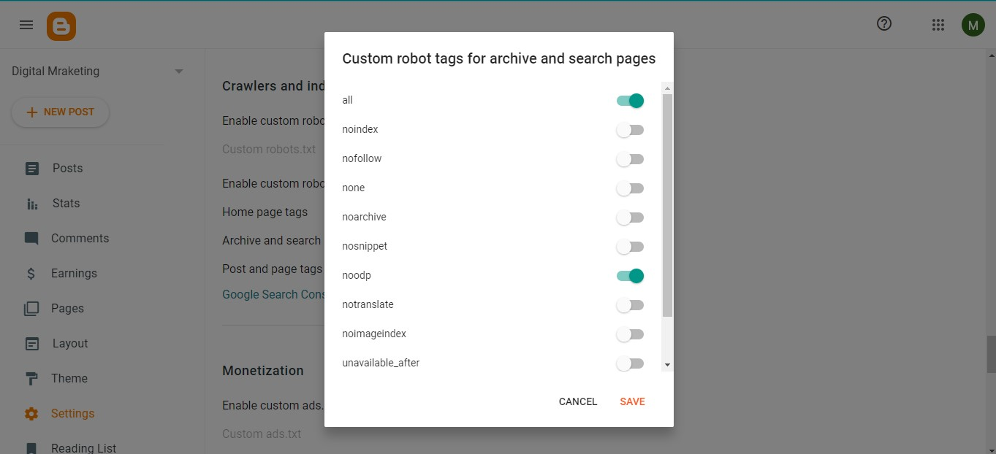

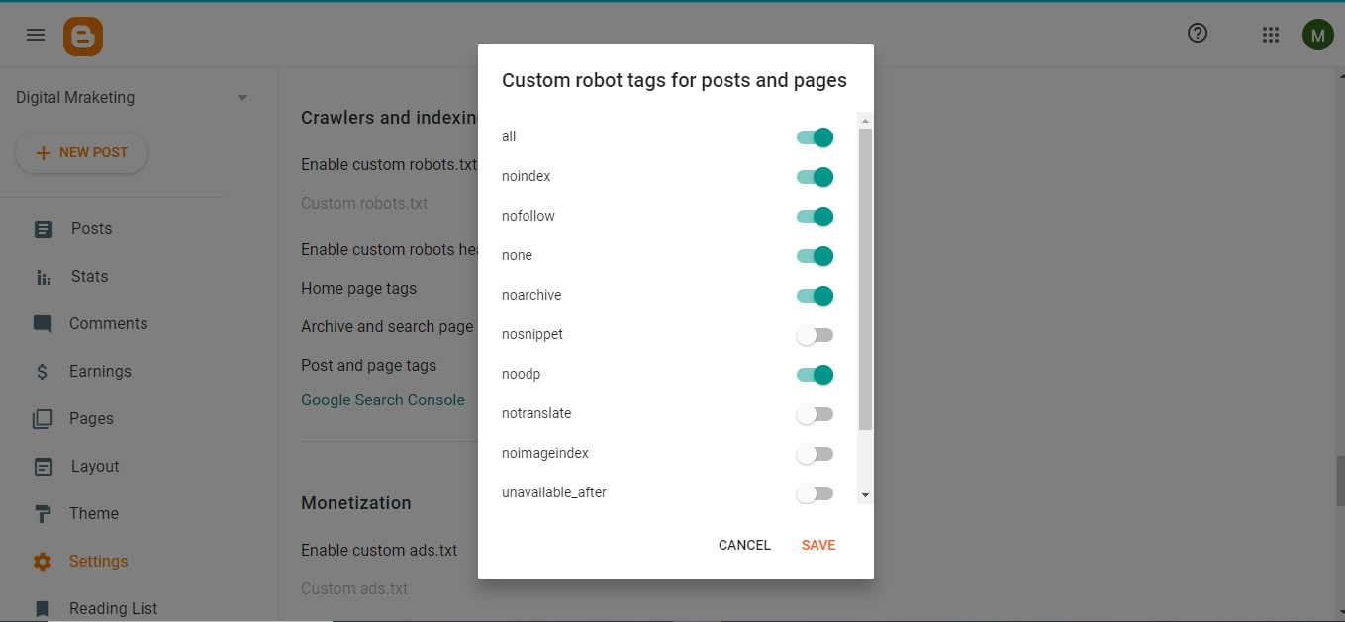

# What are on–pages and off-pages optimization?

On-page optimization and off-page optimization are two important components of search engine optimization (SEO).

**On-page optimization** refers to the various techniques used to optimize the content and HTML source code of a webpage in order to improve its search engine rankings. This includes optimizing the title and meta tags, headers, images, internal linking, keyword density, and overall content quality.

**Off-page optimization**, on the other hand, refers to the various techniques used to improve a website’s search engine rankings that occur outside of the actual website. This includes building high-quality backlinks from other websites, social media marketing, guest blogging, influencer outreach, and other tactics that help to build a website’s online reputation and authority.

In summary, on-page optimization focuses on optimizing individual web pages to rank higher and earn more relevant traffic in search engines, while off-page optimization focuses on improving the website’s overall authority and reputation in order to improve its search engine rankings.

## Perform an on-page SEO using available tools for

<https://www.tops-int.com>

**CURRENT POSITION ON SERP**

IOS course in Rajkot:-

Result at 1” position.

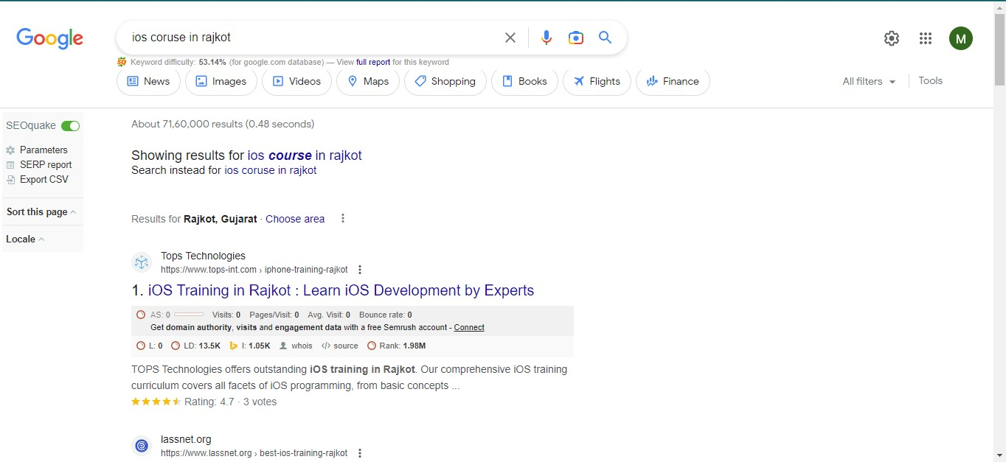

Web Development course in Rajkot:-

Result at 1” position.

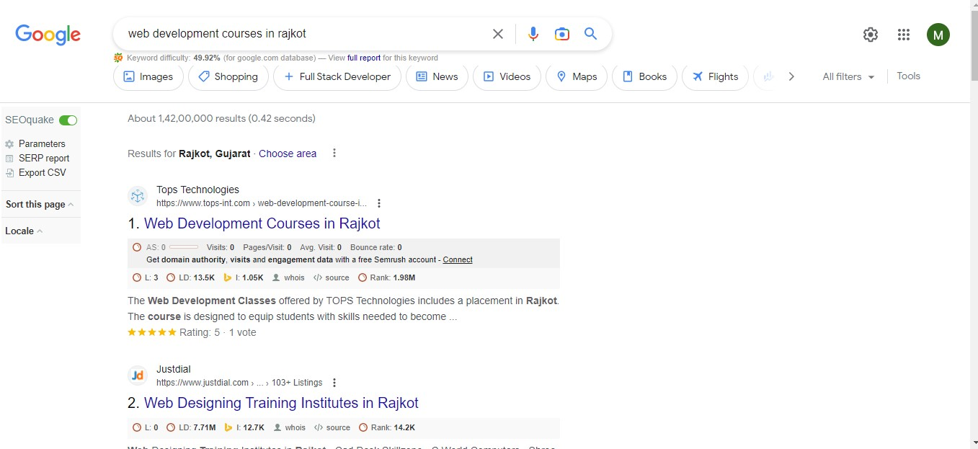

Mobile App Development courses in Rajkot:-

Result at 1” position.

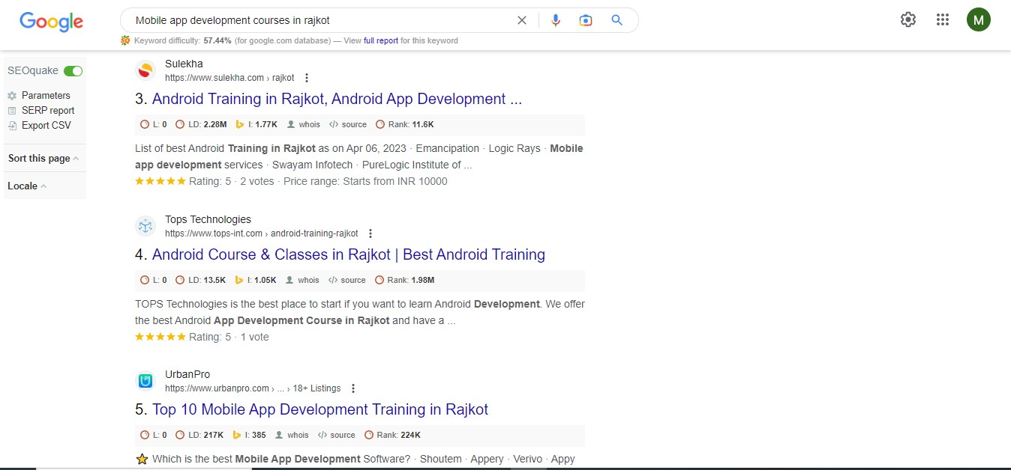

Artificial Intelligence course in Rajkot:-

Result at 11” position.

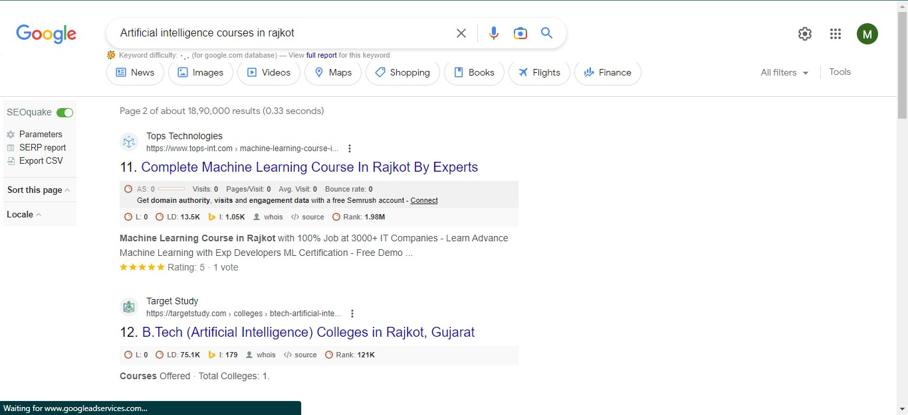

## Prepare complete on-page and off-page SEO audit reports for

## [www.esellerhub.com](http://www.esellerhub.com)

On-page SEO Audit Report:

1. Title Tags:-The title tag is an essential on-page element that should accurately describe the content of the page. The title tags for most of the pages on esellerhub.com are concise, relevant, and unique. However, some of the pages have missing or duplicate title tags, which could negatively impact their search engine ranking.
2. Meta Descriptions:-Meta descriptions provide a summary of the click-through rate from search engine results pages. Most of the pages on esellerhub.com have meta descriptions that are well-written and informative. However, some pages have missing or duplicate meta descriptions, which could negatively impact their search engine rankings.
3. Header Tags:-The use of header tags (H1, H2, H3, etc.) can help search engines understand the structure and hierarchy of the content on a page. Most of the pages on esellerhub.com have appropriate and well-structured header tags. However, some pages have missing or improperly structured header tags, which could negatively impact their search engine rankings.
4. Content Quality:-High-quality, relevant, and informative content is crucial for on-page SEO. The content is generally of good quality, but some pages could benefit from more detailed and comprehensive information. Also, some pages have thin content, which could negatively impact their search engine rankings.
5. Page Speed:-Page speed is a crucial factor for on-page SEO as it affects user experience. According to Google Page Speed Insights, the website’s mobile and desktop speeds are above average, but there are still some opportunities for improvement

Off-Page SEO Audit Report:-

1. Backlinks: Backlinks are an important off-page SEO factor as they indicate the website’s authority and trustworthiness. Esellerhub.com has a decent number of backlinks from reputable sources. However, there are still opportunities for acquiring high-quality backlinks, which could further improve the website’s search engine rankings.
2. Social Media presence: Social media can help increase brand awareness, drive traffic, and improve search engine rankings. Esellerhub.com has a presence on various social media platforms, including Facebook, Twitter, and LinkedIn. However, some platforms could benefit from more regular and consistent posting.
3. Local SEO: If esellerhub.com targets local customers, optimizing for local SEO could improve its visibility in local search results. The website has a Google My Business profile, but some information is missing or outdated. Also, the website could benefit from more local citations and reviews.
4. Mobile Optimization: Mobile optimization is

## What are the characteristics of “bad links”?

“Bad links” are links that can have a negative impact on a website’s search engine rankings or reputation. Here are some characteristics of bad links:

1. **Irrelevant or unrelated links:** Links from websites that haveno relevance to the content of your website can be considered bad links. For example, if you run a website about car repairs or online gambling would be irrelevant and potentially harmful.
2. **Low-quality or spammy links:** Links from websites with poor-quality content or that engage in spammy tactics such as link exchanges or buying links can be considered bad links.
3. **Links from penalized or banned websites:** Links from websites that have been penalized or banned by search engines can also harm your website’s rankings. These websites may have to engage in black-hat SEO practices, such as keyword stuffing or cloaking, which violate search engine guidelines.
4. **Unnatural Links:** Links that appear to have been artificially created, such as those from link farms or automated link-building software, can also be harmful. These types of links do not provide any real value to users and are typically created solely to manipulate search engine rankings.
5. **Broken links or redirects:** Links that lead to broken pages or that redirect users to unrelated content can also be considered bad links. These types of links can frustrate users and damage the credibility of your website.

Overall, it’s important to focus on building high-quality, relevant links that provide real value to users, rather than trying to manipulate search engine ranking with bad links.

## Perform keyword Research then create a blog on “Importance of IT Training” and provide a link to TOPS Technologies and connect it with the webmaster and Google Analytics.

### https://rajkotdm.blogspot.com/2023/04/of-it-training-it-information.html

## What is the use of local SEO?

If you are an official business there is a huge value in investing time and efforts in local SEO. Basically what you are doing is promoting your business for local leads. If done correctly the search engines will rank your pages more than competitors from out of the country. For example, a person in Mumbai is searching for an Italian restaurant it makes the most sense to show results that are in close proximity to the user’s area.

So if the local setting is done correctly you can generate a lot more leads with your local listings.

And the best part is your phone number is also shown there so if a user is searching on the very important to keep the name, address, and phone numbers similar across all the properties and listings. In your listing ensure you upload pictures of your off-storefront rent, and store hours. The last thing to remember is the keywords and categories you want your listing to appear in. If your primary business is an Italian restaurant make sure you get listed in that category if you also have deserts and catering services try and list in those categories.

Now that your basic local listing is ready try and get as many reviews from clients as it will help you rank higher in the local search results.